IC LM324
CP032
Image:
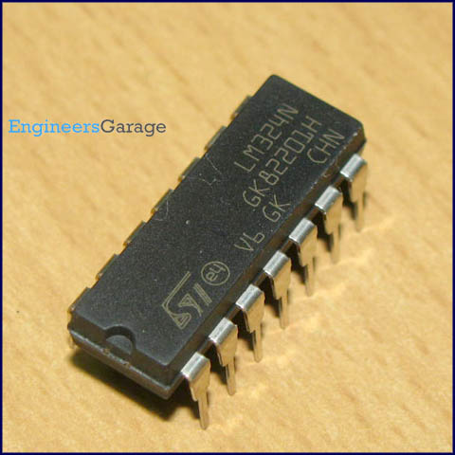
DataSheet:
LM324.pdf
LM324 is a 14pin IC consisting of four independent operational amplifiers (op-amps) compensated in a single package. Op-amps are high gain electronic voltage amplifier with differential input and, usually, a single-ended output. The output voltage is many times higher than the voltage difference between input terminals of an op-amp.
These op-amps are operated by a single power supply LM324 and need for a dual supply is eliminated. They can be used as amplifiers, comparators, oscillators, rectifiers etc. The conventional op-amp applications can be more easily implemented with LM324.
Pin Diagram:
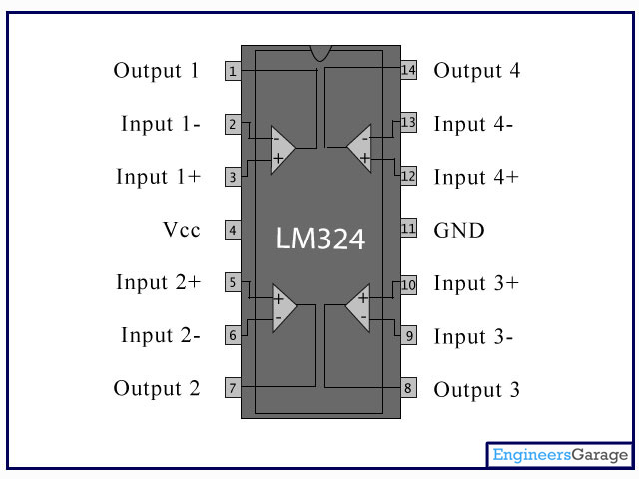
Pin Description:
Pin No | Function | Name
1 | Output of 1st comparator | Output 1
2 | Inverting input of 1st comparator | Input 1-
3 | Non-inverting input of 1st comparator | Input 1+
4 | Supply voltage; 5V (up to 32V) | Vcc
5 | Non-inverting input of 2nd comparator | Input 2+
6 | Inverting input of 2nd comparator | Input 2-
7 | Output of 2nd comparator | Output 2
8 | Output of 3rd comparator | Output 3
9 | Inverting input of 3rd comparator | Input 3-
10 | Non-inverting input of 3rd comparator | Input 3+
11 | Ground (0V) | Ground
12 | Non-inverting input of 4th comparator | Input 4+
13 | Inverting input of 4th comparator | Input 4-
14 | Output of 4th comparator | Output 4

